Steps to perform combination data from different sheets using power query formula:

1. Open get data --🡪 From other sources -🡪 blank query

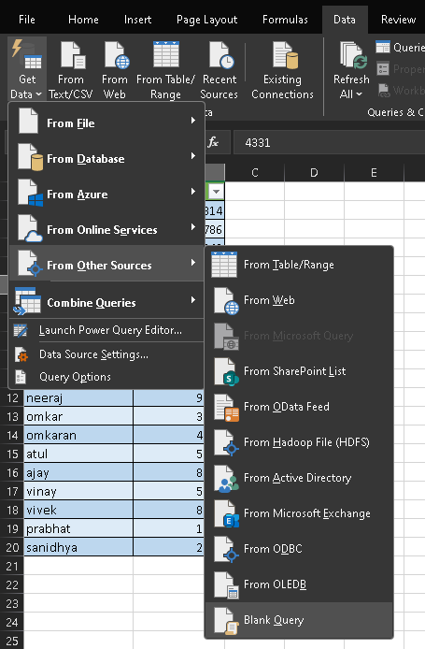

1. When you will open the blank space -🡪 then power query window will get opened then you have to type the formula in the formula bar

Eg. =Excel.CurrentWorkbook

This is case sensitive formula .. you have to write the formula in proper case …because it is an macro recorded formula 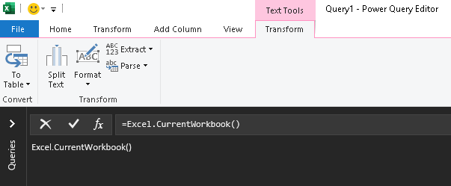

When you hit enter after writing the formula , an window will get opened like shown below

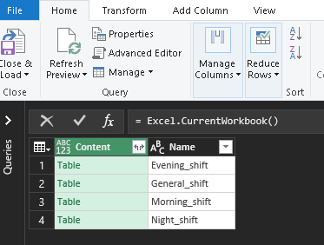

If you click any of the table shown here in green color .. then after clicking on that the whole table’s data will get opened

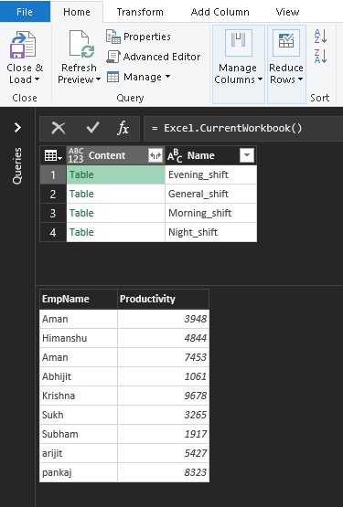

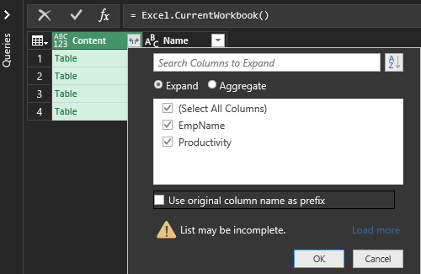

When you will click on the left-right symbol shown ,  .. then an window will get opened .. remember to uncheck the “ use original columns name as prefix”

Then press close & load

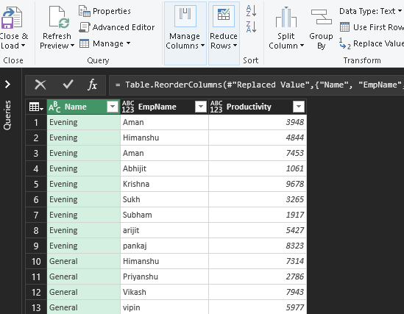

All your data will get combined but .. when you will referesh the extra rows will get added

Then to solve this error .. double click on the queries & connections



Go to source data

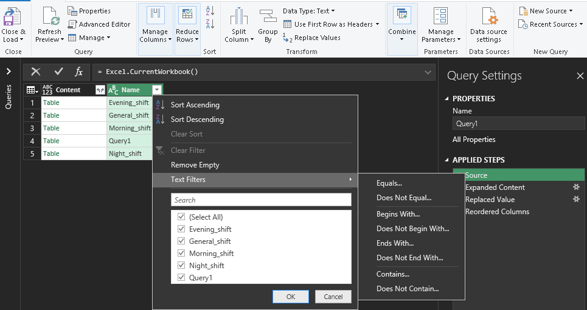

When you referesh the page shown upside in the ribbon .. an extra query1 row is shows which is continuously adding in the backend of dat .. so to remove this error ..

Open the drop down button of names , an window will get opened 🡪 select text filters and select “Ends with”

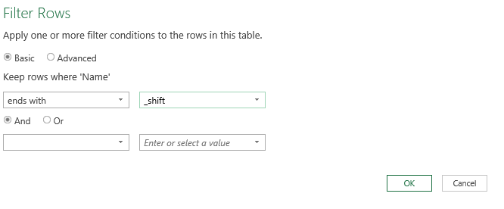

Press ok … after all this .. now when you close & load ..and if you refresh … no extra rows will added to combined data ..